KARNATAK LAW SOCIETY’S

GOGTE INSTITUTE OF TECHNOLOGY

UDYAMBAG, BELAGAVI-590008

(An Autonomous Institution under Visvesvaraya Technological University, Belagavi)

**(APPROVED BY AICTE, NEW DELHI)**

Department of Electronics and Communication Engineering



*Course Project Report on*

**C/CPP- Lab**

**Program to print the berth of a railway seat number.**

*Submitted in partial fulfilment of the requirement for the award of the degree of*

**Bachelor of Engineering**

**in**

***Electronics & Communication  
Submitted by***

**Harshally Mutgekar 2GI17EC037 (A Div)  
Priyadarshani Desai 2GI17EC085(B Div)**

**Guide**

Prof . U.U.Deshpande

**2019 – 2020**

**Objective :**

Program to print the berth of given railway seat number

Given a railway seat number, the task is to check whether it is a valid seat number or not. Also print its berth type i.e lower berth, middle berth, upper berth, side lower berth, side upper berth as per the figure below.

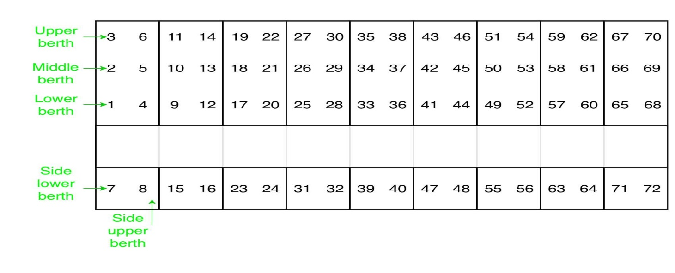

Check if seat number is valid seat number or not(i.e in range of 1 to 72).

1. if (seat_number % 8) equals 1 or 4, then berth is a lower berth
2. if (seat_number % 8) equals 2 or 5, then berth is a middle berth
3. if (seat_number % 8) equals 3 or 6, then berth is an upper berth
4. if (seat_number % 8) equals 7, then berth is a side lower berth
5. if (seat_number % 8) equals 0 then berth is a side upper berth

**C Code** :

// C program to print berth type of a provided seat number.

//Railway portal

#include <stdio.h>

// function to print berth type

void berth_type(int s)

{

if (s > 0 && s < 73)

if (s % 8 == 1 ||

s % 8 == 4)

printf("%d is lower berth\n", s);

else if (s % 8 == 2 ||

s % 8 == 5)

printf("%d is middle berth\n",s);

else if(s % 8 == 3 ||

s % 8 == 6)

printf("%d is upper berth\n",s);

else if(s % 8 == 7)

printf("%d is side lower berth\n",s);

else

printf("%d is side upper berth\n",s);

else

printf("%d invalid seat number\n",s);

}

int main()

{

int s;

printf("\n\n \t\t Welcome to RAILWAYS Portal \n\n ");

printf("\n\n \t\t We have 72 seats available in Qwerty-Express \n\n ");

printf("\n\n \t\t Your preferred seat no : \n\n ");

scanf( "%d",&s);

berth_type(s);

return 0;

}

**Output :**

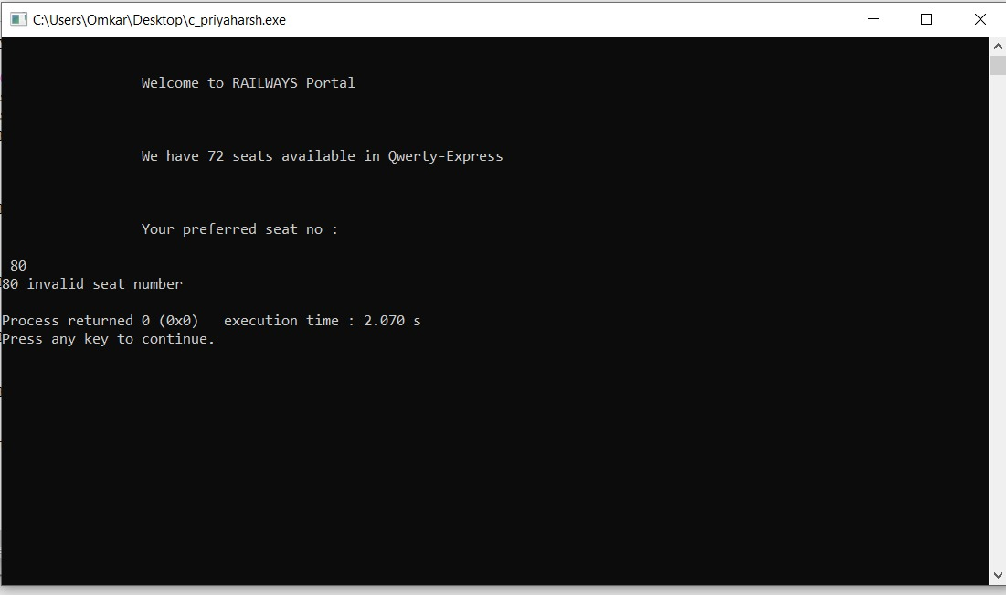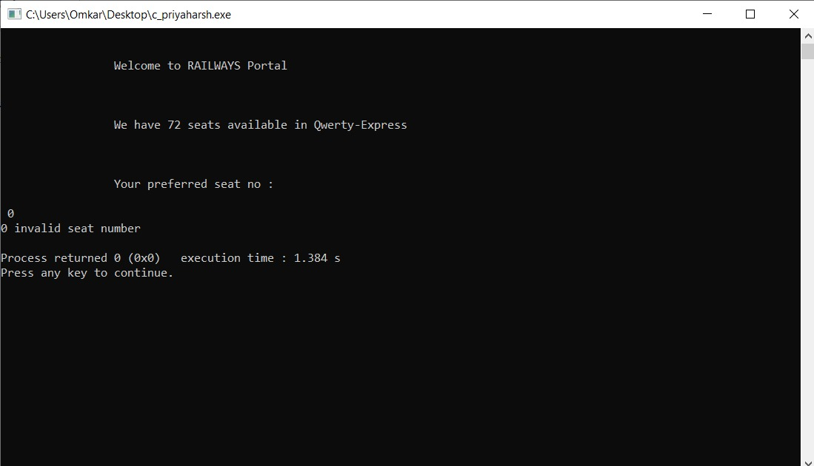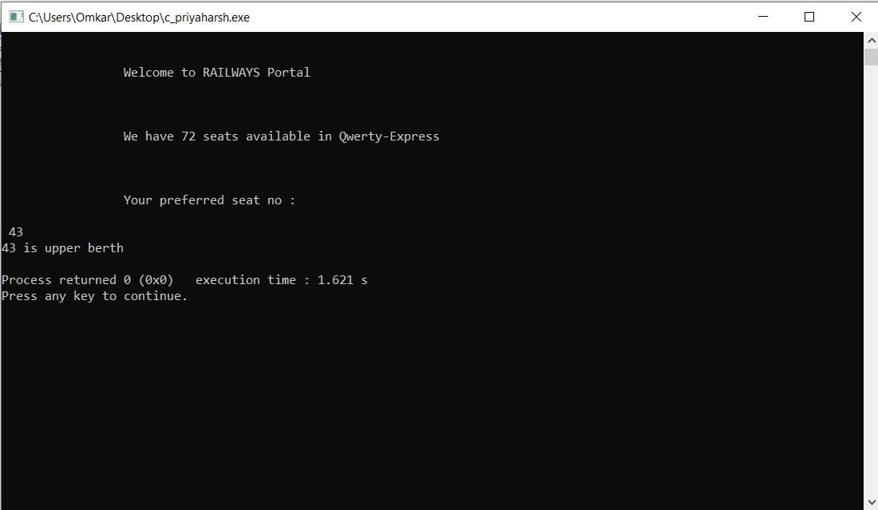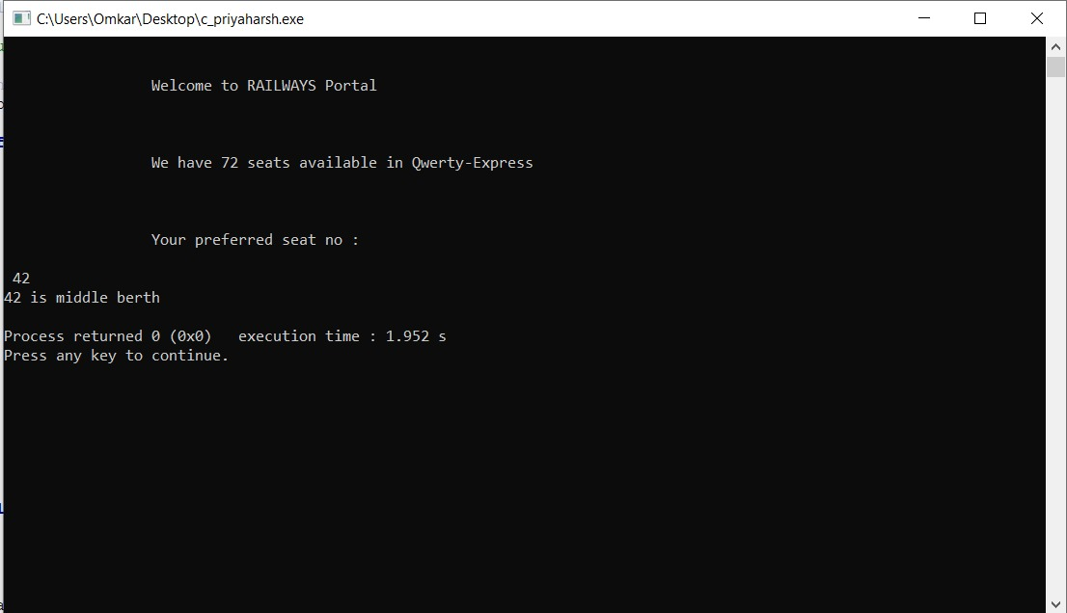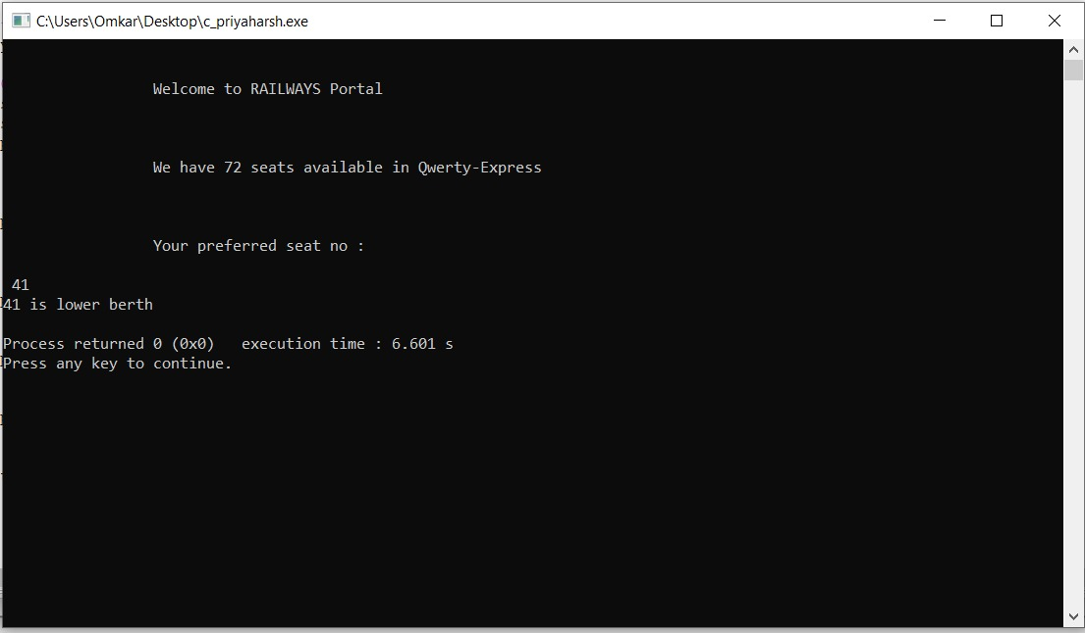

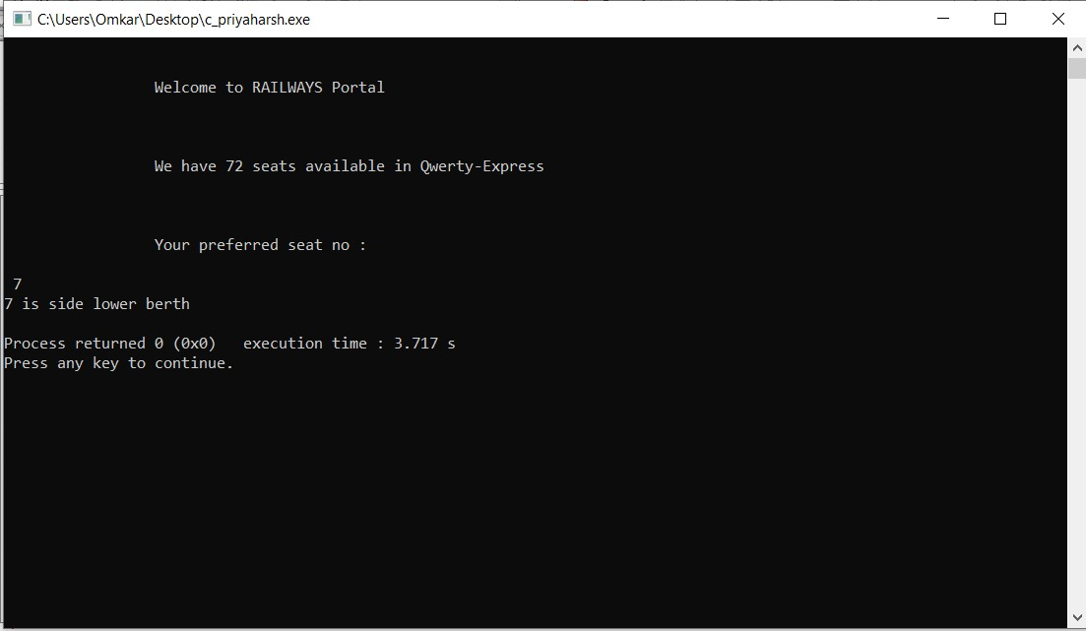

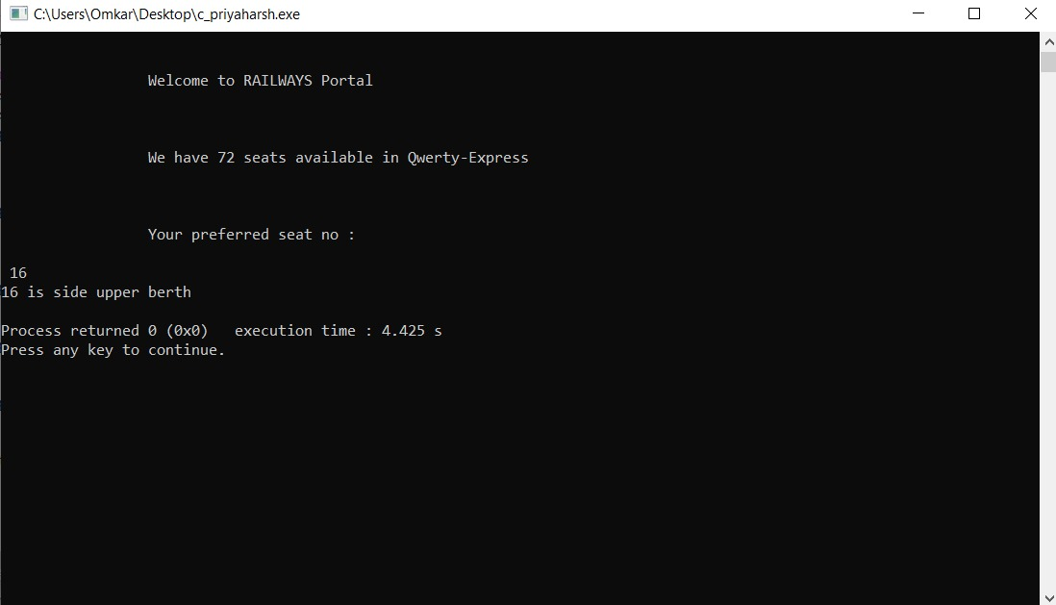

**Result :**

Hence we obtain the following output which shows your booked seat position.